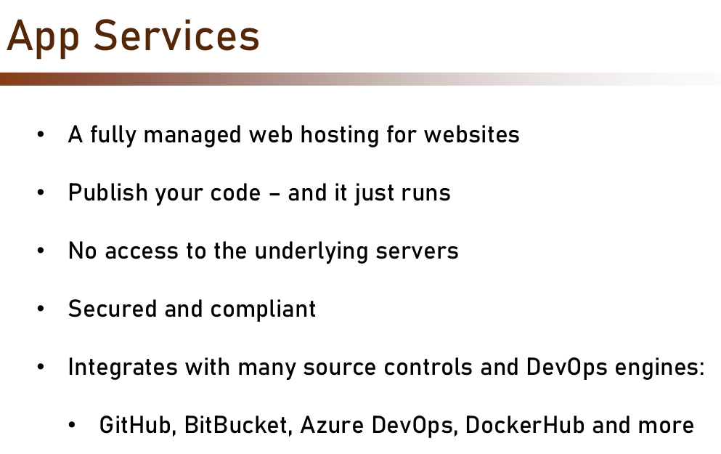

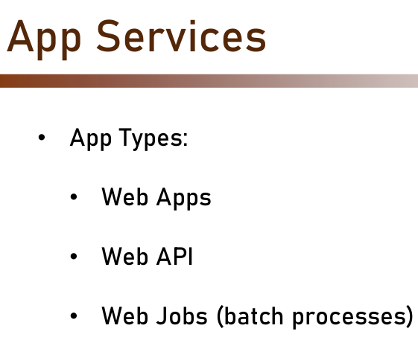

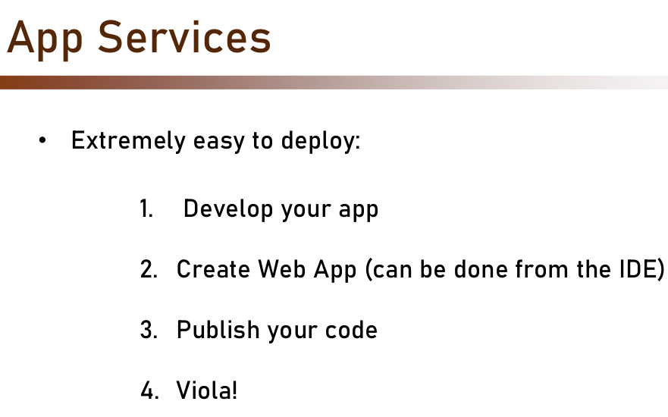
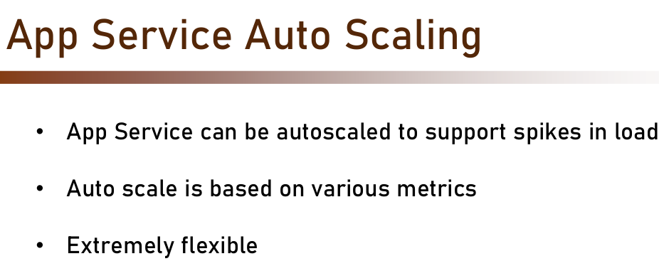

Deploy an ASP.NET web app

https://learn.microsoft.com/en-us/azure/app-service/quickstart-dotnetcore?tabs=net60&pivots=development-environment-vscode

Deploy an ASP.NET Core and Azure SQL Database app to Azure App Service

https://learn.microsoft.com/en-us/azure/app-service/tutorial-dotnetcore-sqldb-app?tabs=azure-portal%2Cvisualstudio-deploy%2Cdeploy-instructions-azure-portal%2Cazure-portal-logs%2Cazure-portal-resources

Create a Node.js web app in Azure

https://learn.microsoft.com/en-us/azure/app-service/quickstart-nodejs?tabs=linux&pivots=development-environment-vscode

Deploy a Node.js + MongoDB web app to Azure

https://dev.to/bjhaid_93/deploy-a-node-js-express-mongodb-api-to-azure-app-service-via-visual-studio-code-58ln

https://github.com/abejide001/node-azure-appservice

Create a Java app on Azure App Service

https://learn.microsoft.com/en-us/azure/app-service/quickstart-java?tabs=javase&pivots=platform-linux-development-environment-maven

Deploy a Python (Django or Flask) web app to Azure App Service

https://learn.microsoft.com/en-us/azure/app-service/quickstart-python?tabs=flask%2Cmac-linux%2Cvscode-aztools%2Cvscode-deploy%2Cdeploy-instructions-azportal%2Cterminal-bash%2Cdeploy-instructions-zip-azcli

Create a WordPress site

https://learn.microsoft.com/en-us/azure/app-service/quickstart-wordpress

Build a Java Spring Boot web app with Azure App Service on Linux and Azure Cosmos DB

https://learn.microsoft.com/en-us/azure/app-service/tutorial-java-spring-cosmosdb

